Website Revamp & Google Ecosystem Migration Strategy

The Bradbury Group (AI Consulting & Learning Solutions)
Based on the current website structure and Paige Bradbury's positioning around AI consulting, AI training, AI adoption, and agentic workflows, the goal should not be a simple redesign. It should become an AI-first business platform capable of scaling into courses, memberships, AI assistants, digital products, corporate training, and automated lead generation.

Phase 1: Strategic Shift

Current State Problems
The existing website appears to function primarily as a marketing website:
- Static pages
- Traditional contact forms
- Content-heavy navigation
- Limited personalization
- No AI-driven user journey
- No automated qualification of leads
- No digital learning ecosystem
The website should evolve into:

AI-Powered Learning & Consulting Platform
Where visitors can:
- Learn AI
- Book consultations
- Access resources
- Chat with AI assistants
- Join cohorts
- Purchase courses
- Schedule workshops
- Access knowledge bases without requiring human intervention for every touchpoint.
Compatible and scalable for Agentic infrastructure and ability to integrate with CRM (Click up), marketing tools like Hubspot.
For The Bradbury Group, I would specifically design it as an Agentic Business Platform, not just a website.

Agentic Infrastructure Compatibility - Architecture
Website (Next.js)
↓
Firebase / Firestore
↓
Gemini / Vertex AI
↓
Agent Layer
↓
HubSpot / ClickUp / Email / Calendar
↓
Human Team
Every action on the website becomes an event that an AI agent can process.
Example:
Visitor completes:
AI Readiness Assessment
↓
Gemini evaluates score
↓
Creates HubSpot lead
↓
Assigns ClickUp task
↓
Schedules follow-up sequence
↓
Generates proposal draft
↓
Notifies Paige
without manual intervention.

ClickUp Integration
I would strongly recommend integrating ClickUp as the operational backend.

What Can Be Automated

New Lead
Website Form
↓
HubSpot Contact
↓
ClickUp Task Created
↓
Assigned to Team
↓
Due Date Generated
↓
Follow-up Triggered
Corporate Training Inquiry
Visitor submits:
- Company
- Team Size
- Industry
↓
AI evaluates opportunity
↓
Creates ClickUp project
↓
Creates checklist
↓
Generates proposal draft
↓
Assigns owner

Workshop Booking
User books workshop
↓
Task created
↓
Calendar invite
↓
Resource pack generated
↓
Follow-up workflow initiated

HubSpot Compatibility
Excellent compatibility.
Actually HubSpot should become:

Marketing Brain
while ClickUp becomes:

Delivery Brain

Recommended Google-Centric Architecture

Frontend

Option A (Recommended)

Next.js
Why:
- SEO friendly ( Consider AEO and GEO too)
- Fast loading
- Google optimized
- Future-proof
- AI Studio integrations easier

GEO Website Architecture
Instead of:
Service Page
AI Training Services
(500 words of marketing copy)

Create:
AI Literacy Training for Organizations

Include:
What is AI Literacy?
Why Organizations Need AI Literacy
Common Challenges
Implementation Framework
Cost Estimates
FAQs
Case Studies
Statistics
Citations
AI systems prefer structured knowledge.
Entity Building Strategy
Google and AI engines now rank entities more than keywords.

The entity should become:
Paige Bradbury

Associated with:
AI Adoption
AI Literacy
Corporate AI Training
Learning & Development
AI Transformation
Every page should reinforce these associations.

Website Structure for GEO
Pillar Pages
AI Literacy
3000–5000 words

AI Adoption Framework
3000–5000 words

AI Governance
3000–5000 words

AI for Learning & Development
3000–5000 words

AI Workforce Transformation
3000–5000 words

These become AI-citable resources.

AEO Structure
Every page should include:
Direct Answers

Bad:
"We help organizations unlock AI potential."

Good:
"AI Literacy Training is a structured learning program that helps employees understand, evaluate, and safely use artificial intelligence in their daily work."
This is answer-engine friendly.
FAQ Blocks
Every page should have 10–20 FAQs.

Example:
What is AI Literacy?
How long does AI training take?
What industries benefit from AI adoption?
How much does AI consulting cost?

Google AI Overview loves FAQ structures.
Schema Markup

Implement:
Organization Schema
Person Schema
For Paige Bradbury
FAQ Schema
Article Schema
Course Schema
Event Schema
Review Schema
Video Schema
This dramatically increases AI discoverability.
GEO Content Hub

Create:
Resource Center

Categories:
AI Adoption
AI Leadership
Prompt Engineering
AI Governance
AI Literacy
Learning & Development

Every article becomes part of a semantic knowledge graph.
AI Studio Integration for GEO
Use Gemini to generate:
Long-form Pillar Content
FAQ Libraries
Industry-Specific Landing Pages
Webinar Summaries
Research Reports
Executive Briefings
All reviewed by humans before publishing.
Future-Proof Architecture
Vertex AI Search

This is where Google's ecosystem becomes powerful.
Upload:
PDFs
Whitepapers
Webinars
Training Materials
Research Reports

Users can ask:
"What are Bradbury's recommendations for AI governance?"
Gemini answers directly from Bradbury's knowledge base.
Now the website becomes an AI-powered knowledge platform.

Technical - GEO Stack
Frontend - Next.js
Hosting - Firebase
CMS - Sanity CMS or Contentful
AI - Gemini
Search - Vertex AI Search
Database - Firestore
Analytics - GA4 + BigQuery
Reporting - Looker Studio
CRM - HubSpot

Hosted on:

Google Firebase Hosting
Benefits:
- Global CDN
- SSL included
- Serverless deployment
- Low cost
Estimated:
$0–25/month initially

Backend

Firebase
Replace traditional hosting + WordPress.
Use:

Firebase Authentication
For:
- User login
- Membership access
- Course access

Firestore Database
For:
- Leads
- Clients
- Course progress
- Chat history
- Knowledge base
Frontend (Next.js)
↓
Agent Gateway Layer
↓
| Gemini
| Columbus
| Solomon
| OpenAI
| Claude
| Perplexity
| Future Models
↓
Business Services Layer
↓
Firestore / CRM / LMS / ClickUp

Cloud Functions
For:
- Automations
- Email workflows
- AI processes

Complete Google Stack
Function | Tool
Website | Next.js
Hosting | Firebase Hosting
Database | Firestore
Authentication | Firebase Auth
File Storage | Google Cloud Storage
Analytics | GA4
Heatmaps | Microsoft Clarity
Search Console | Google Search Console
CRM | HubSpot Free
AI | Gemini
Email | Google Workspace
Automation | Make / n8n
Knowledge Base | Vertex AI Search

AI Studio Integration Strategy

Google AI Studio
Use Gemini Models for:

Website Assistant
Example:
Visitor asks:
"Which AI training is best for my team?"
AI immediately responds.

Course Recommendation Agent
AI recommends:
- Beginner AI Program
- Manager AI Program
- Executive AI Program
based on answers.

Proposal Generator
Visitor fills:
- Company size
- Industry
- AI maturity
AI generates:
- PDF proposal
- Scope
- Budget estimate instantly.

Corporate Training Advisor
AI recommends:
- Workshops
- Learning paths
- Certifications
without human involvement.

Multi-Agent Architecture (Future)
Google Gemini can power multiple agents.

Agent 1
Sales Assistant
Handles:
- Discovery
- Lead qualification
- Booking calls

Agent 2
Learning Coach
Handles:
- Course guidance
- Q&A
- Progress tracking
Agent 3
Content Agent
Handles:
- Blog recommendations
- Resource navigation

Agent 4
Internal Team Agent
Used by Bradbury team.
Can answer:
- SOPs
- Processes
- Training material

Information Architecture

New Navigation

Home
Hero
AI Transformation for Learning Leaders

Services
- AI Consulting
- AI Workshops
- AI Enablement
- Custom GPT Solutions
- AI Strategy

Training
- AI Foundations
- AI Leadership
- AI for L&D
- AI Certification

Resources
- Blog
- Templates
- Prompt Library
- Guides

Community
- Membership
- Events
- Webinars

About
- Paige
- Team
- Success Stories

Contact
Book Consultation

Homepage Structure

Section 1
Hero
Headline:
"Helping Organizations Build an AI-Enabled Workforce."
CTA:
Book Strategy Session

Section 2
Trusted By
Client logos

Section 3
AI Maturity Assessment
Interactive tool
Powered by Gemini

Section 4
Services
Cards

Section 5

Case Studies

Section 6

AI Assistant
Persistent chat widget

Section 7
Resources

Section 8
Book Consultation

SEO Strategy
Google-first architecture means:

Programmatic SEO
Create:
- AI in Education
- AI for HR
- AI for L&D
Landing pages.
Each optimized individually.

Blog Automation
Gemini drafts articles.
Human reviews.
Publish automatically.
Result:
50–100 SEO pages annually.

Knowledge Base Architecture
Store:
- PDFs
- Playbooks
- Course materials
- Webinar transcripts
- Client documents
inside:

Google Cloud Storage
Then connect:

Vertex AI Search
Users can ask:
"Find all content about prompt engineering."
and get AI-generated answers.

CRM Architecture
Recommended:

HubSpot Free CRM
Integrations:
- Website
- Forms
- Chatbot
- Email
Lead flow:
Website
↓
HubSpot
↓
AI Qualification
↓
Meeting Scheduler

Analytics Stack

Google Analytics 4
Track:
- Form submissions
- CTA clicks
- Downloads
- AI chatbot usage

BigQuery
Export GA4 data.
Create dashboards.

Looker Studio
Executive dashboards.

Migration Plan

Phase 1 (2 Weeks)
Audit
- Pages
- Content
- SEO
- Assets

Phase 2 (3 Weeks)
UX Strategy
- Site architecture
- User journeys
- Wireframes

Phase 3 (4 Weeks)
Design System
- Typography
- Components
- Brand refresh
Built in Figma.

Phase 4 (4–6 Weeks)
Development
Next.js + Firebase

Phase 5 (2 Weeks)
AI Integration
Gemini
AI Studio
Vertex AI

Phase 6 (1 Week)
Testing
- SEO
- Performance
- Accessibility
- Security
Phase 7
Go Live
Redirects
Analytics
Search Console

Estimated Monthly Cost
Service | Cost
Firebase Hosting | $0–25
Firestore | $5–50
Google Storage | $5–20
Gemini API | $10–100
Workspace | $6–12/user
HubSpot | Free
Clarity | Free
GA4 | Free

Total
Startup Stage:
$30–100/month
Growth Stage:
$150–500/month
Enterprise Scale:
$1,000+/month

Recommendation for Paige Bradbury
Do not migrate to WordPress on Google Hosting.
Build:
Next.js + Firebase + Gemini + Firestore + Vertex AI + HubSpot
This gives:
✅ Lowest maintenance cost
✅ Fastest performance
✅ AI-native architecture
✅ Google ecosystem alignment
✅ Course platform readiness
✅ Membership readiness
✅ Multi-agent AI future
✅ Scalable to 100,000+ users without rebuilding
For your roadmap document, position this as "The Bradbury Group AI-Native Digital Ecosystem Transformation", not merely a website redesign. This aligns with Paige's vision of creating a company built around AI assistants, AI workflows, and human expertise.
Reference websites from Paige:

https://www.correlation-one.com/

https://aimusings.site/

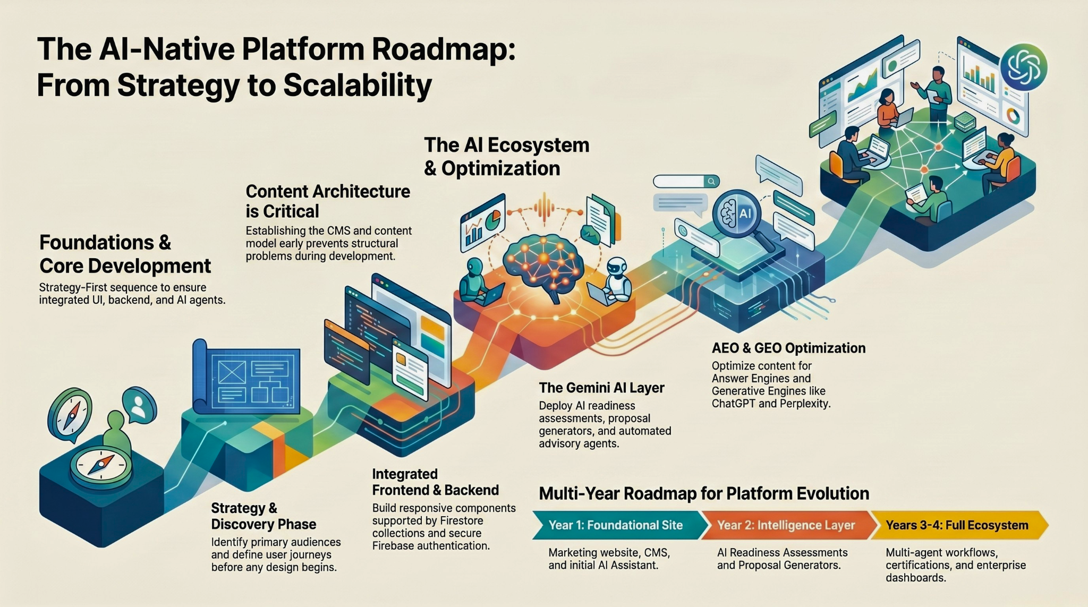

Native OS Inputs:

The summer camp curriculum is structured around the following five modules that map exactly to what we called the "AI Native Growth OS Initiative". We can select which of these modules to focus on for TBG.
- Communication OS - agents interact with customers through your existing channels
- Intelligence OS - converts messy inputs (PDFs, emails, training content) into structured, queryable data
- Production OS - agents produce the actual deliverables
- Trust & Verification OS - outputs are sourced, audited, and defensible before they go out
- Pipeline Growth OS - each engagement automatically surfaces the next opportunity
Paige, in our March call, you said: "The future belongs to those who can design how work gets done, not just do it. That's exactly what this builds: the system that does the work, with you and Aparna designing and governing it.
Timeline: I'm on vacation June 27 through July 10. Active build starts July 13. By October 5, the goal is a working agent fleet for TBG.
System Access: I'd phase this depending on the need.
- ClickUp - editor/admin access (CRM structure, automations, workflows)
- MailerLite - admin access (sequences, subscriber data, automation builder)
- Columbus - documentation or developer access so I can see what data it captures and where it routes
Aparna, you mentioned in March that Columbus currently routes to a centralized intake account and emails to Paige for manual filtering. We would need to discuss if you want to keep that as is or have the agent fleet close it. As we go deeper, I'd also want read access to n8n, Google Forms, and the Vercel/Supabase setup - but those three are the starting point.
Architecture: To your question about ClickUp and WordPress as command centers - the Growth OS doesn't replace them. ClickUp stays as your CRM and project hub. The Growth OS adds an agent layer on top that operates those tools autonomously, plus:
- A knowledge system that makes Paige's training content, curriculum modules, and partnership context accessible to agents
- A communication layer so you can interact naturally - chat, voice, Slack, whatever works for you two
- A trust layer so nothing goes out without the right checkpoints (this was a concern we flagged in March - no defined approver in the content pipeline)
Since the website is under revamp, that's fine. The agent layer doesn't depend on it - it'll adapt to whatever the site becomes.

